What is the Effect of High Government Debt on Productivity?

Ian Tufts

George Washington University

November 14, 2021

Background:

Productivity is widely cited as one of the most fundamental determinants of economic wellbeing. Despite the fact that it is a somewhat amorphous term, it nonetheless helps to explain why some countries are more prosperous than others. The most significant determinant of productivity is a country’s capital stock, which in turn comes from saved resources which are invested.
It is on the point of investment in the capital stock that government debt comes into play. When the government runs a budget deficit, the resulting debt has interest payments that must be met via government taxation. Regardless of how a government chooses to finance the interest payments, it will eventually have to tax some more of people’s resources for payment. However, if more resources must be taxed, then there is less savings left over for investment in the future. Much economic research has already highlighted the relationship between government debt and GDP growth. In their influential paper on the subject, Reinhart and Rogoff (2010) concluded that “…across both advanced countries and emerging markets, high debt/GDP levels (90 percent and above) are associated with notably lower growth outcomes” (p. 577). The result is that there is less capital investment, of which the second-order effect is slower productivity growth. This means that issues regarding government debt will likely become of huge importance in the future, due to the massive debts that were accumulated by the U.S. government in response to COVID-19, with the total U.S. government debt at 129% of GDP at the end of 2020 (Federal Reserve Bank of St. Louis, 2020).

Research Question:

The purpose of this research paper is to assess the following research question: Does the level of government debt influence long-term productivity growth rates? My expectation is that if the level of government debt, as a percentage of GDP, is very high, then productivity growth will be slower than if the level of government debt is fairly low. If in fact the prediction is true, then it would support previous research, such as one study by Afonso and Jalles (2013), who found that “…countries with debt ratios above 90% of GDP are associated with lower economic growth rates when compared with countries that maintained an average debt ratio below 30% of GDP over the period under scrutiny” (p. 402).

Hypotheses:

My research will involve using a regression analysis test to see if there is a statistically significant relationship between government debt and labor productivity growth. In particular, the test will be used to see if there is a statistically significant effect of the level of government debt, as a percentage of GDP, on labor productivity, as measured by output per hour of work.
For this analysis, the linear regression will have the format$μ_{y}=β_{0}+β_{1}x$. In the general model, $μ_{y}$ is average productivity growth, $β_{0}$ is the intercept, $x$ is government debt (as percentage of GDP), and $β_{1}$ is the change in $μ_{y}$ per unit change in $x$. The hypothesis test will test whether the value of $β_{1}$ is statistically significant or not.
H0: $β_{1}$= 0 ($β_{1}$ is not statistically significant; a linear relationship does not exist.) Ha: $β_{1}$ ≠ 0 ($β_{1}$ is statistically significant; a linear relationship does exist.)

Data & Method:

The data analysis involved two sets OECD data of 34 countries in the European Union, the English-speaking offshoots, and Latin America. The two data sets were the level of government debt, measured as a percentage of GDP, and labor productivity, measured as GDP

per labor hours. The data span the 24-year period of 1995-2019. After importing both data sets, the average over the 24-year period for both variables was taken for every country. Japan was ultimately not included in the analysis, as the Cook’s distance measure indicated it was a statistical outlier with high leverage.
For the remaining 33 countries, the 24-year averages for labor productivity growth were used to construct a simple linear regression model. Additionally, the data were checked to see if they were in violation of any assumptions that go into running the analysis. The graph titled “Residuals vs Fitted” indicates that there is not constant variance among the data. However, the graph titled “Normal Q-Q” indicated that the data are pretty close to being normally distributed, though not perfectly.

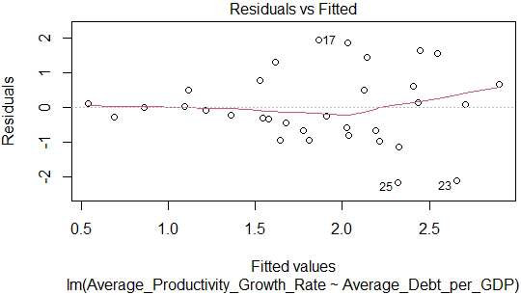

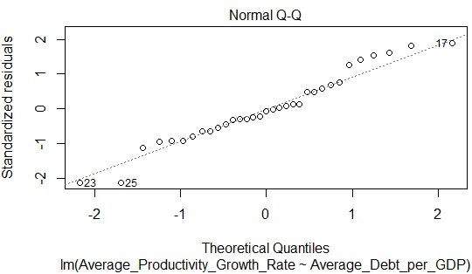

Findings & Limitations:

Upon running the regression analysis, the estimate for the linear regression was:

$Avg Productivity Growth=3.101836-0.018719\left(Avg Debt per GDP\right)$.

This regression estimate can be interpreted as indicating that, for every 1-unit in a country’s debt-to-GDP ratio, there will be, on average, about a 0.019% decrease in average labor productivity growth. The regression analysis also gave a t-statistic of $t^{*}$= −3.196, a p-value of
$p$ = 0.00319, and a R² value of $R^{2}$= 0.2479, all shown in the summary table below. The R² value should be interpreted as indicating that about 24.79% of the variation in productivity growth can be explained by the variation in government debt. In this case, the p-value is less than
0.01. This means that we can reject the null hypothesis, H0, that $β_{1}$, the change in $μ_{y}$ per unit change in 𝑥, is not statistically significant. In other words, this means that the level of government debt appears to have a statistically significant effect of the rate of labor productivity growth. The linear regression is displayed in the scatterplot shown below.

Coefficient | Estimate | Standard  Error | T-Statistic | P-Value | R2
(Intercept) | 3.101836 | 0.429201 | 7.227 | 3.96e-08 | N/A
Average Debt per GDP  (𝛽𝛽1) | -0.018719 | 0.005856 | -3.196 | 0.00319 | 0.2479
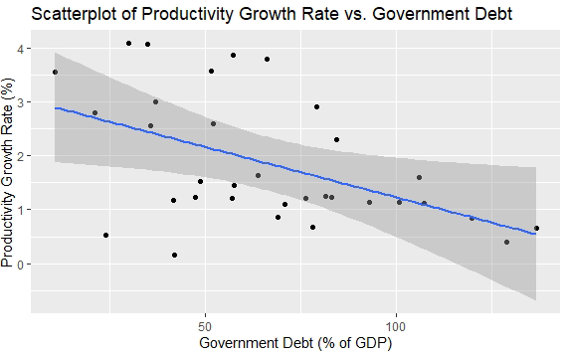

There are a couple of limitations to this research and the regression analysis involved.

The first being that the variance is not constant among the data, which is an important assumption to make when doing regression analysis. Another limitation is the possibility of omitted variable bias. That is, it is possible that there are other factors or variables that could influence a country’s productivity growth, such as the interest rate on the government debt or a country’s political economy.

Conclusion:

The primary conclusion of this paper is that there does appear to be relationship, albeit a small one, between a country’s level of government debt and the rate of growth in labor productivity, as measured by output per hour of work. As mentioned before, this relationship has already been documented by previous research. For instance, Woo and Kumar (2015) found that “…on average, a 10-percentage point increase in the initial debt-to-GDP ratio is associated with a slowdown in real per capita GDP growth of around 0.2 percentage points per year…” (p. 729). In conclusion, the findings of this paper support prior findings that the level of government debt matters for the rate of productivity growth. That, in turn, matters for a country’s long-term economic prospects in the future.

References:

Afonso, A., & Jalles, J.T. (2013), Growth and productivity: The role of government debt.
International Review of Economics & Finance, 25, 384-407. https://doi.org/10.1016/j.iref.2012.07.004

Federal Reserve Bank of St. Louis. (2020). Federal Debt: Total Public Debt as Percent of Gross Domestic Product (GFDEGDQ188S) [Data Set]. FRED, Federal Reserve Bank of St.
Louis. https://fred.stlouisfed.org/series/GFDEGDQ188S

Reinhart, C.M., & Rogoff, K.S. (2010). Growth in a Time of Debt. The American Economic Review, 100(2), 573-578, from http://www.jstor.org/stable/27805061

Woo, J., & Kumar, M.S. (2015). Public Debt and Growth. Economica, 82, 705-739. https://doi-org.proxygw.wrlc.org/10.1111/ecca.12138

Data Sources:

Organisation for Economic Co-operation and Development. (2021). Labour productivity and utilisation (indicator) [Data Set]. Organisation for Economic Co-operation and Development. https://data.oecd.org/lprdty/labour-productivity-and- utilisation.htm#indicator-chart

Organisation for Economic Co-operation and Development. (2021). General government debt (indicator) [Data Set]. Organisation for Economic Co-operation and Development. https://data.oecd.org/gga/general-government-debt.htm#indicator-chart

